**Molecular Statics Lab 1**

1. All tests passed in Matlab grader for part 1.

2. All tests passed in Matlab grader for part 2.

3. Energy versus atomic spacing for both the computational and analytical solutions are plotted below. The magnitude of the analytical plot has been adjusted to be similar to that of the computational plot. The derivative was used to determine the minimum energy for the analytical solution, the point at which the derivatives is zero. The minimum for each solution is shown below and the analytical derivative is also plotted.

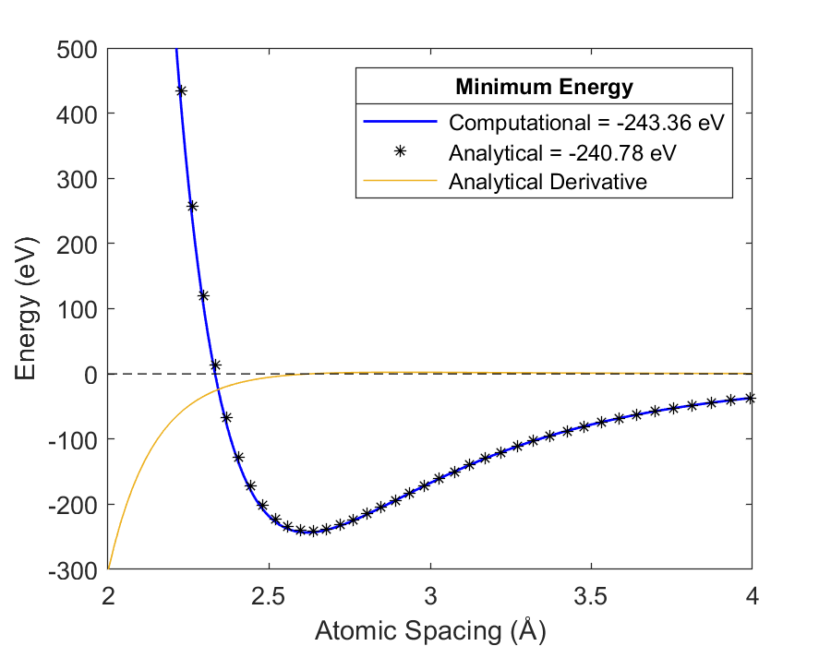

The following is a plot of the force on each atom of a 50-atom chain plotted along the length of the chain. The force in the middle of all chains is essentially zero. The equilibrium spacing exhibits the minimum amount of force on either end of the chain. A spacing slightly more or less than the equilibrium spacing will increase the magnitude of the force on the ends of the chain.

